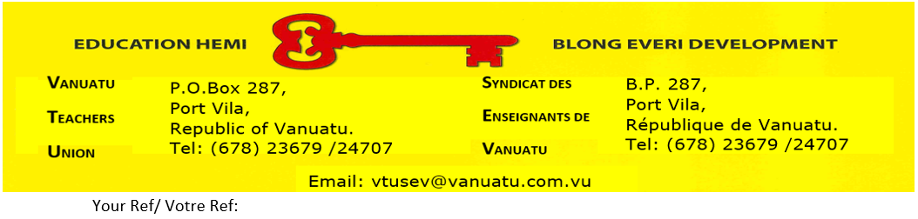

VTU MEDICAL CLAIM FORM

SURNAME__________________________ FIRST NAMES__________________________
* PLEASE COMPLETE: NAME OF BANK & A/C No._____________________

- ALL COLUMS VNPF No___________
- A SEPARATE LINE FOR EACH AMOUNT CLAIMED
* PLEASE ATTACH AN INVOICE FOR EACH AMOUNT CLAIMED
* PLEASE CLEARLY IDENTIFY THE TYPE OF INJURY, SICKNESS OR TREATMENT
Please do not put the words “consultation” as a reason for type of injury,sickness or treatment.
The actual illness must be given – eg. Flu, bloodpressure, broken arm, infection to leg etc.

Name of the  Insured person  (yourself,  spouse, child) | Name of the  Hospital, clinic,  Doctor, etc | Has account  been paid  Yes/No | Type of injury  Sickness or  treatment | Day injury  Occurred or  Symptoms  appeared | Date of  Treatment or  Period of  confinement | Amount  incurred
VANUATU TEACHER UNION

